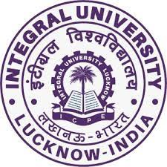

**Department of Languages**

**Integral University**

**Board of Studies Meeting for National Education Policy -2022 onwards**

**BA English**

**Brief Report**

A Board of Studies Meeting was organized by Dr. H.M. Arif Nadvi, Head, Department of Languages, Integral University for finalization of BA English syllabus as per National Education Policy. The meeting was graced by Dr. R.P. Singh, External Expert and Professor, Department of English and Modern European Languages, Lucknow University. The meeting was presented and attended by:

1. Dr. H.M. Arif Nadvi, Head, Department of Languages, Integral University

2. Dr. S.W. Mohsin, Associate Professor, Department of Languages, Integral University

3. Dr. Mursalin Jahan, Assistant Professor, Department of Languages, Integral University

4. Dr. Aareena Nazneen, Assistant Professor and NEP Coordinator, Department of Languages, Integral University

5. Ms. Vanya Srivastava, Assistant Professor and NEP Coordinator, Department of Languages, Integral University

6. Dr. Naseem, Assistant Professor and Internal Expert NEP, Department of Chemistry, Integral University

